**3. RECTIFIERS**

**3.1 OBJECTIVE**

a. To study the operation of active diode circuits (precisions circuits) using op-amps, such as half wave rectifier and full wave rectifier

|  |  |  |  |  |  |  |  |  |  |  |  |  |  |  |  |  |  |  |  |  |  |  |  |  |  |  |  |  |  |  |  |  |
| --- | --- | --- | --- | --- | --- | --- | --- | --- | --- | --- | --- | --- | --- | --- | --- | --- | --- | --- | --- | --- | --- | --- | --- | --- | --- | --- | --- | --- | --- | --- | --- | --- |
| * 1. **HARDWARE REQUIRED**  |  |  |  |  | | --- | --- | --- | --- | | **S.No** | **Equipment/Component name** | **Specifications/Value** | **Quantity** | | 1 | IC 741 | Refer data sheet in appendix | 1 | | 2 | Cathode Ray Oscilloscope | (0 – 20MHz) 1 | 1 | | 3 | Resistors | 10 K Ω | 6 | | 4 | Semiconductor(Diode) | 1N4002 | 2 | | 5 | Dual Regulated power supply | (0 -30V), 1A | 1 | | 6 | Function Generator | (0-2) MHz | 1 | | 7 | ASLK PRO Kit | Refer data sheet in appendix | 1 | |

**3.3 THEORY**

The major limitation of ordinary diodes is that it cannot rectify voltage below 0.6v, thecut in voltage of the diode. The precision rectifier, which is also known as a super diode, is a configuration obtained with an operational amplifier in order to have a circuit behaving like an ideal diode and rectifier. It can be useful for high-precision signal processing.

**3.3.1 Active Half Wave Rectifier**

Op-amps can enhance the performance of diode circuits. For one thing, the op-amp can eliminate the effect of diode offset voltage, allowing us to rectify, peak-detect, clip, and clamp low-level signals (those with amplitudes smaller than the offset voltage). And because of their buffering action op-amps can eliminate the effects of source and load on diode circuits. Circuits that combine op-amps and diodes are called active diode circuits. Fig. (a) shows an active HWR, with gain.

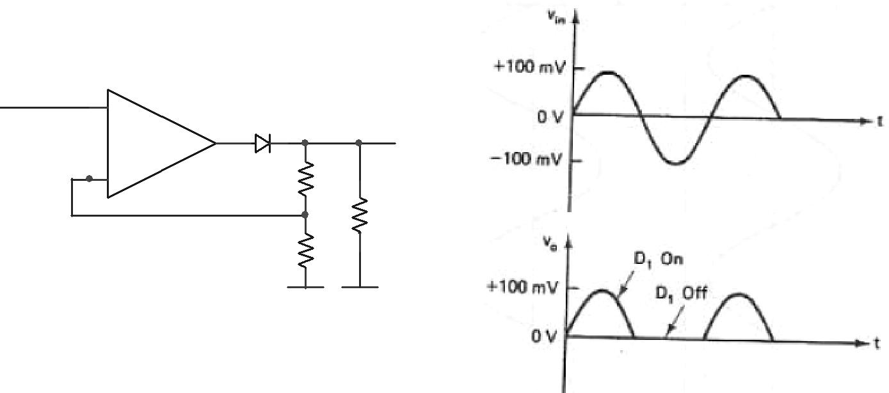

Vi

|  |  |  |
| --- | --- | --- |
| **+** | D1 |  |
| uA741 |  |
| Vo |  |
| **-** | R1 |  |
|  | RL |  |
|  | R2 |  |

***Fig(a)*** *Active HWR, (b) input and output waveforms*

When the input signal goes positive, the op-amp goes positive and turns on the diode. The circuit then acts as a conventional non-inverting amplifier, and the positive half-cycle appears across the load resistor. On the other hand, when the input goes negative, the op-amp output goes negative and turns off the diode. Since the diode is open, no voltage appears across the load resistor. This is why the final output is almost a perfect half-wave signal.

The high gain of the op-amp virtually eliminates the effect of offset voltage. For instance, if the offset voltage equals 0.7V and open-loop gain is 100,000, the input that just turns on the diode is

|  |  |  |  |  |  |
| --- | --- | --- | --- | --- | --- |
| *Vin*= |  | 0.7*V* |  |  |  |
| 100,000 | |  |
|  |  |  |  |

When the input is greater than 7µV, the diode turns on and the circuit acts like a voltage follower. The effect is equivalent to reducing the offset voltage by a factor of A.

The active HWR is useful with low-level signals. For instance, if we want to measure sinusoidal voltages in the millivolt region, we can add a milli ammeter in series with RL with the proper value of RL, we can calibrate the meter to indicate rms millivolts.

* + 1. **Design Constraints**
* The output signal is limited by the IC's power sources: the output signal cannot be greater than +15V
  + 1. **Experiment**

1. Connect the circuit as shown in the figure. Consider all resistors value 10kΩ . Use 1N4002 diodes. Assemble the circuit.
2. Feed sinusoidal input of amplitude 200mVPP and frequency 100Hz. Using a CRO observe the input and output voltages simultaneously. Determine the amplitude and frequency of the output voltage.
3. Increase the frequency of the input signal till distortion appears in the output. Record this frequency in the below table
4. Plot the input and output voltages on the same scale.

|  |  |  |  |
| --- | --- | --- | --- |
| Particulars | Amplitude | Time period | Frequency |
| Input Voltage |  |  |  |
| Output Voltage |  |  |  |

**3.3.4 Full Wave Rectifier**

A Full Wave Rectifier is a circuit, which converts an ac voltage into a pulsating dc voltage using both half cycles of the applied ac voltage. It uses two diodes of which one conducts during one half cycle while the other conducts during the other half cycle of the applied ac voltage.

During the positive half cycle of the input voltage, diode D1 becomes forward biased and D2 becomes reverse biased. Hence D1 conducts and D2 remains OFF. The load current flows through D1 and the voltage drop across RL will be equal to the input voltage. During the negative half cycle of the input voltage, diode D1 becomes reverse biased and D2 becomes forward biased. Hence D1 remains OFF and D2 conducts. The load current flows through D2 and the voltage drop across RL will be equal to the input voltage.

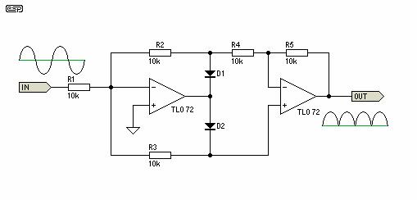

Input waveform

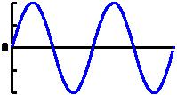

Output waveform:

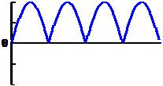

Fig (a) Full wave rectifier, (b) input and output waveforms

**Experiment**

1. Connect the circuit as shown in the figure. Consider all resistors value 10kΩ . Use 1N4002 diodes. Assemble the circuit.
2. Feed sinusoidal input of amplitude 200mVPP and frequency 100Hz.
3. Using a CRO observe the input and output voltages simultaneously. Determine the amplitude and frequency of the output voltage. Increase the frequency of the input signal till distortion appears in the output. Record this frequency in the below table.
4. Plot the input and output voltages on the same scale.

|  |  |  |  |
| --- | --- | --- | --- |
| Particulars | Amplitude | Time period | Frequency |
| Input Voltage |  |  |  |
| Output Voltage |  |  |  |